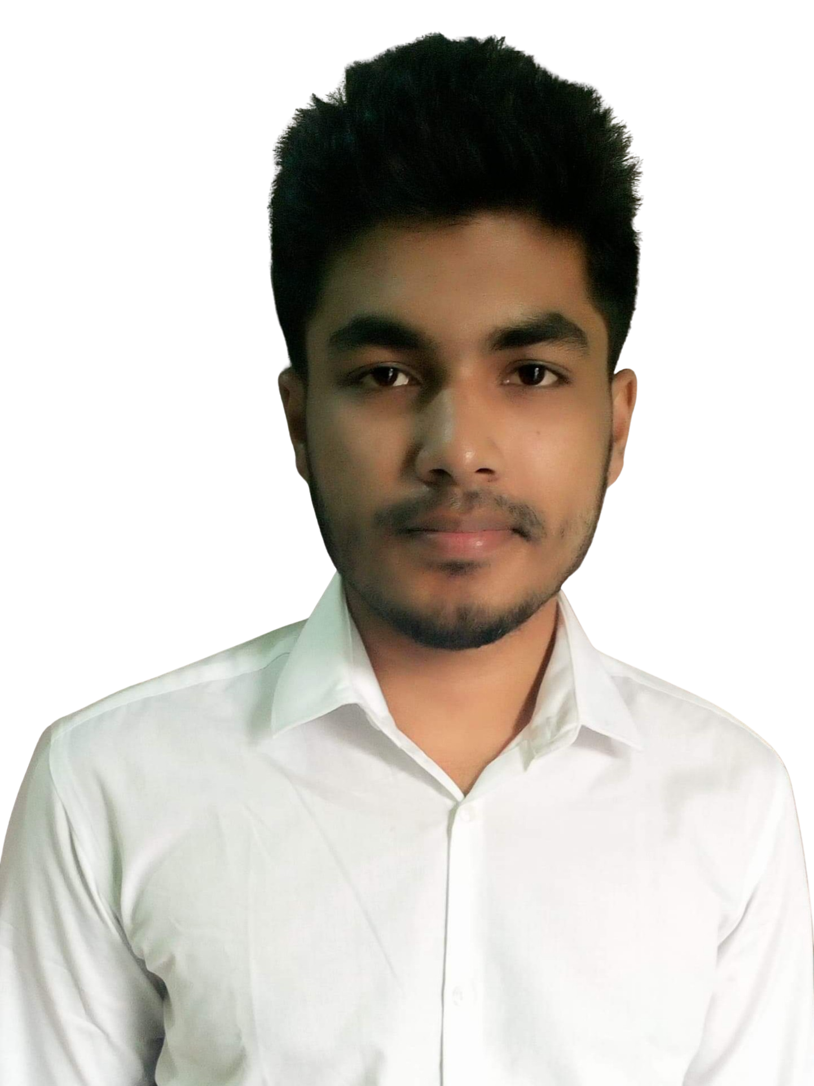

**Hasibul Islam**

**Web Application Developer**

**Phone:** +8801575428813

**E-mail:** hasibulislam1670@gmail.com

**Address:**Naraynganj,Bangladesh

**My Portfolio :**[**Hasibul Islam**](https://hasibul1670.github.io/hasibulislam)

**Career Objective:**

An enthusiastic and driven Computer Science last semester student seeking a Software Development Intern to expand my knowledge of Javascripts,HTML5,CSS3,ReactJs,Bootstrap,tailwind css. I am eager to work independently and collaboratively as part of a team while utilising my analytical and problem-solving skills to contribute to the growth and success of the organisation.

**Technical Skills:**

* **Languages :** C#,C++, JavaScript,
* **Frameworks :** Bootstrap, React.js
* **Databases :** MongoDB.
* **IDEs :** Visual Studio Code,Visual Studio, CodeBlocks
* **Version Control:**Github

**Professional Experience:**

**● An Electronic Journal Website**

**Github:** [Github Repository link](https://github.com/hasibul1670/Electronic-Journal-client)

**Technology:** JavaScript, React, Node.js, Express.js, Bootstrap, MongoDB, Firebase Authentication,

**● Creative-Agency Website**

**Github:** [Github Repository link](https://github.com/hasibul1670/creative-agency-client)

**Technology:** JavaScript, React, Node.js, Express.js, Bootstrap, MongoDB, Firebase Authentication,

**●Volunteer-Network Website**

**Visit Website:** [**Live Website Link**](https://volunteer-network365.netlify.app)

**Github:** [Github Repository link](https://github.com/hasibul1670/volunteer-network)

**Technology:** JavaScript, React, Node.js, Express.js, Bootstrap, MongoDB, Firebase

**●WhatsApp Clone**

**Github:** [**Github Repository Link**](https://github.com/hasibul1670/whatsaapp)

**Technology:**  React, Bootstrap, Material UI, Firebase Authentication, Cloud FireStore..

**Academic Background:**

**Degree:** B.Sc. in Computer Science and Engineering (Sep 2018 - Now)

**University:** National University (Dhaka City College)

**CGPA:** 3.67(Till now)

**Languages:**

**●** Bangla

**●** English